Rectangling the Square – August 2023
Donald Bell – donald@marchland.org
filename: rectangling_the_square.docx

Background
Many years ago, two mathematicians, Bertie Smith and M. den Hertog, showed how to tile a square with rectangles that had no repeated sides | 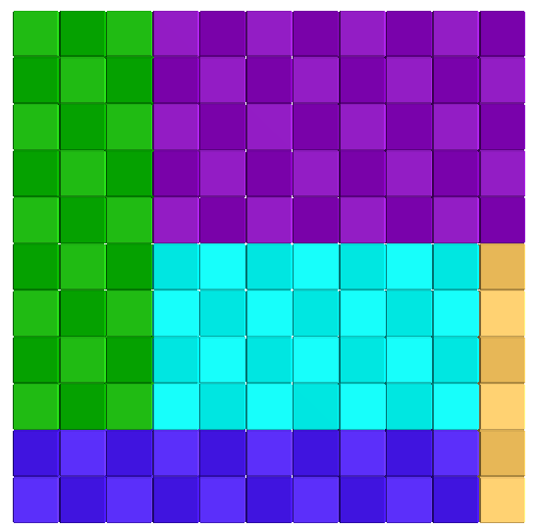 | 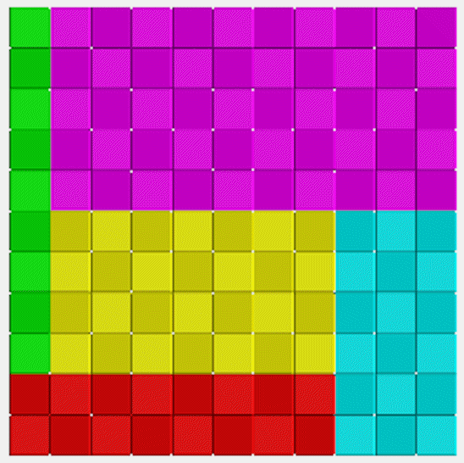
Since there must be at least 5 rectangles, the 10 different sides must have the values 1 to 10 at least. So the squares must be at least 11x11.

It turns out that there are two solutions and the two sets of rectangles are:
[1x6], [2x10], [3x9], [4x7], [5x8] and [1x9], [2x8], [3x6], [4x7], [5x10]

I wrote a Python program to check this out and there are no more solutions.

I wondered if this might be the basis for a (fairly easy) put-together puzzle. If the lengths of all the edges are different, then it will not be too obvious which piece should go in the middle and what way the others should be arranged around it. ϕ
To get some idea of what might be possible, here is a square with rectangles of equal area.  The middle one is a square of side ϕ . It is surrounded by four rectangles whose dimensions are (ϕ + 1) x 1.  To make a puzzle, these dimensions have to be changed a bit. | 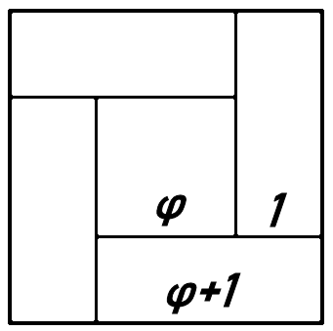
I did not like the long thin rectangles [1x6] and [1x9] in the 11x11 solution. Is it possible to make them a bit fatter?  It turns out that you have to go to a 15x15 square to get rid of all the [1xN] rectangles.  This one is:  [2x12], [3x11], [4x10], [5x13], [7x9] | 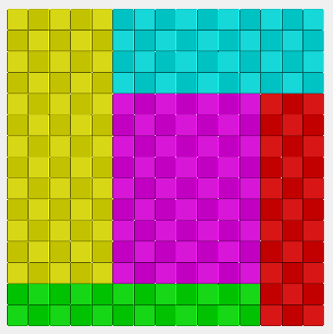
And to also get rid of the [2xN] rectangles, you need to go to a [17x17] square.  The rectangles in this one are:  [3x12], [4x15], [5x14], [6x13], [8x10] | 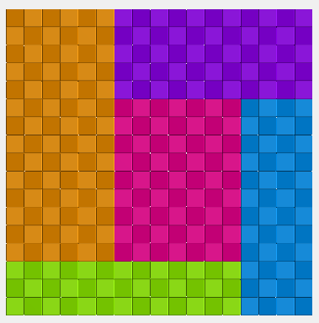
To have the smallest dimension as 4, you need to go to a [20x20] square.  In this one, the areas of each rectangle are as close as possible to one fifth of the area of the square. That is 80 pixels out of 400.  Here the rectangles are:  [4x13], [5x16], [6x15], [7x14], [8x10] | 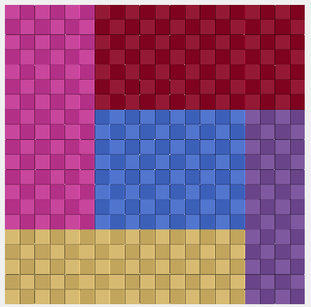
The [12x12] square has an area of 144 pixels. This can be factored in several ways, such as [16x9] and [18x8]. I wondered if the same set of rectangles could tile more than one shape of rectangle or square.  So far, no success. Here is one tiling of the [16x9] rectangle: | 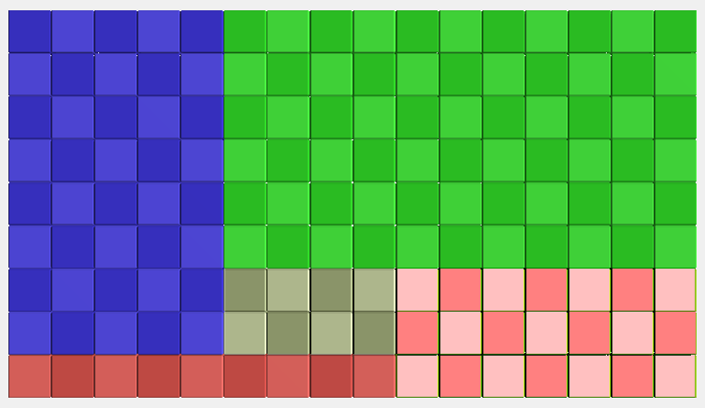
If we go to six rectangles, there might be more scope for a solution.  The sixth piece must obviously fit along one side of the square. An example for a [20x20] square is shown.  The rectangles here are:  [2x20], [3x12], [4x17], [6x13], [7x14], [8x10] | 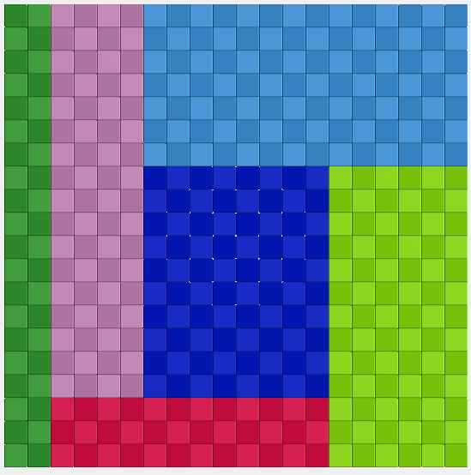
Alas, these will not tile a [25x16] rectangle.

So the unsolved question still remains:

Is there a set of rectangles, with no repeated length of side, that will tile more than one rectangle?

